Guidelines for the Paper for Techno-Societal 2016
First Author¹, Second Author²

¹Address Institute one Including country
² Address Institute one Including country

Abstract. The abstract is a mandatory element that should summarize the contents of the paper and should contain at least 70 and at most 150 words. Abstract and keywords are freely available in SpringerLink. 9 point font size should be used in the abstract and keywords. No academic titles or descriptions of academic positions should be included in the addresses. Either this information should be omitted altogether (preferably), or it should be included in a footnote at the end of the first page. Information of this nature, given in the addresses, will be deleted by our typesetters.
Keywords: We would like to encourage you to list your keywords here. They should be separated by commas. Keywords (except the first one) start with small letters and the last one ends with a dot.
1 Introduction
You will find here guidelines for the preparation of proceedings papers to be published in one of the following series, in printed and electronic form: Please Make sure that number pages of your final paper should not be more than 8 pages.
2 Preparation of Your Paper
2.1 Structuring Your Paper
Affiliations. The affiliated institutions are to be listed directly below the names of the authors. Multiple affiliatons should be marked with superscript arabic numbers, and they should each start on a new line as shown in this document. In addition to the name of your affiliation, we would ask you to give the town and the country in which it is situated. Do not include the entire postal address. E-mail addresses should start on a new line and should be grouped per affiliation.
Headings. Headings should be capitalized (i.e., nouns, verbs, and all other words except articles, prepositions, and conjunctions should be set with an initial capital) and should, with the exception of the title, be aligned to the left. Only the first two levels of section headings should be numbered, as shown in Table 1. The respective font sizes are also given in Table 1. Kindly refrain from using “0” when numbering your section headings.

Table 1. Font sizes of headings. Table captions should always be positioned above the tables.
Heading level | Example | Font size and style
Title (centered) | Lecture Notes | 14 point, bold
1st-level heading | 1 Introduction | 12 point, bold
2nd-level heading | 2.1 Printing Area | 10 point, bold
3rd-level heading | Run-in Heading in Bold. Text follows | 10 point, bold
4th-level heading | Lowest Level Heading. Text follows | 10 point, italic

Words joined by a hyphen are subject to a special rule. If the first word can stand alone, the second word should be capitalized.
2.2 Page Numbering and Running Heads
There is no need to include page numbers or running heads; this will be done at our end. If your paper title is too long to serve as a running head, it will be shortened. Your suggestion as to how to shorten it would be most welcome.
2.3 Figures and Tables
It is essential that all illustrations are as clear and as legible as possible. Vector graphics – instead of rasterized images – should be used for diagrams and schemas whenever possible. Please check that the lines in line drawings are not interrupted and have a constant width. Grids and details within the figures must be clearly legible and may not be written one on top of the other. Line drawings are to have a resolution of at least 800 dpi (preferably 1200 dpi). The lettering in figures should not use font sizes smaller than 6 pt (~ 2 mm character height). Figures are to be numbered and to have a caption which should always be positioned under the figures, in contrast to the caption belonging to a table, which should always appear above the table.

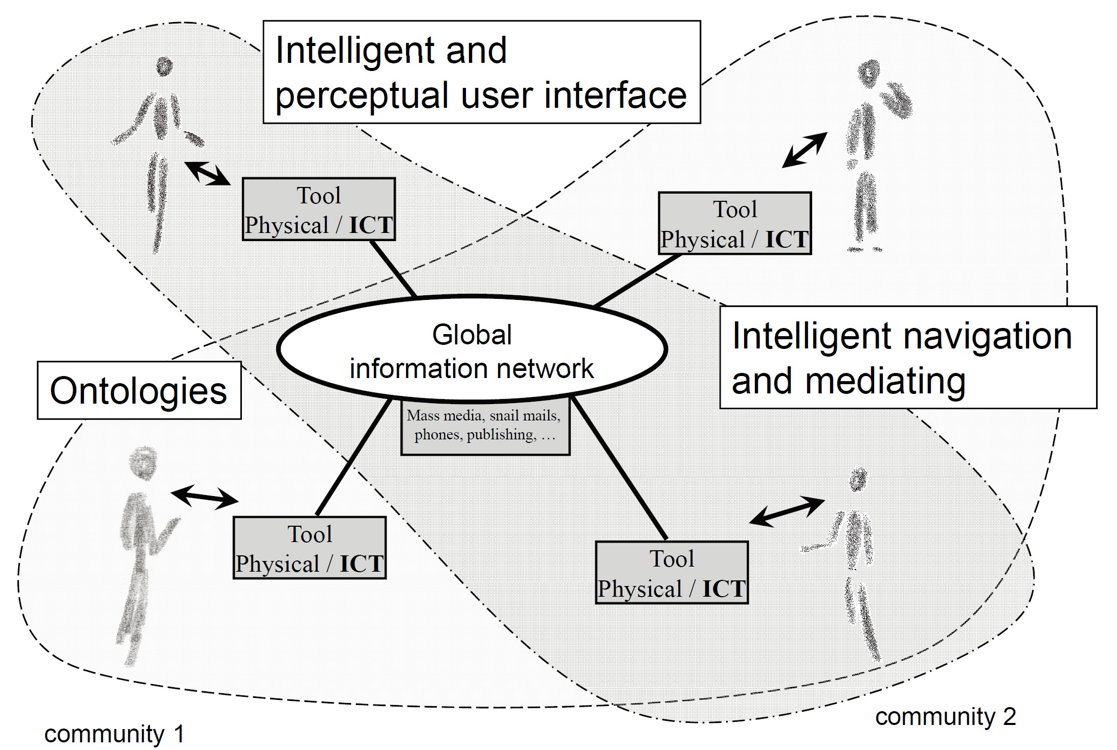

Fig. 1. Artifacts empowered by Artificial Intelligence (Source: LNCS 5640, p. 115)

Captions are set in 9-point type. If they are short, they are centered between the margins. Longer captions, covering more than one line, are justified. Captions that do not constitute a full sentence, do not have a period.
Text fragments of fewer than four lines should not appear at the tops or bottoms of pages, following a table or figure. In such cases, it is better to set the figures right at the top or right at the bottom of the page. A figure should never be placed in the middle of a paragraph.
If screenshots are necessary, please make sure that the essential content is clear to the reader.
Remark 1. In the printed volumes, illustrations are generally black and white (halftones), and only in exceptional cases, and if the author or the conference organization is prepared to cover the extra costs involved, are colored pictures accepted. Colored pictures are welcome in the electronic version free of charge. If you send colored figures that are to be printed in black and white, please make sure that they really are also legible in black and white. Some colors show up very poorly when printed in black and white.
2.4 Formulas
Displayed equations or formulas are centered and set on a separate line (with an extra line or half line space above and below). Displayed expressions should be numbered for reference. The numbers should be consecutive within the contribution, with numbers enclosed in parentheses and set on the right margin. Please do not include section counters in the numbering.

x + y = z (1)

Equations should be punctuated in the same way as ordinary text but with a small space before the end punctuation mark.
2.5 Footnotes
The superscript numeral used to refer to a footnote appears in the text either directly after the word to be discussed or – in relation to a phrase or a sentence – following the punctuation mark (comma, semicolon, or period).
For remarks pertaining to the title or the authors’ names, in the header of a paper, symbols should be used instead of a number. Please note that no footnotes may be included in the abstract. Font size for fotnotes should be 9 point.
2.6 Citations and Bibliography
For citations in the text, use square brackets and consecutive numbers. Numbers should be grouped where appropriate. We would write [1-5] but [1], [3], [5], etc. The numbers in the bibliography section are without square brackets. Page numbers are required for quotations. Page numbers should be indicated in square bracets [5, p.26].
Please write all references using the latin alphabet. If the title of the book you are referring to is, e.g., in Russian or Chinese, then please write (in Russian) or (in Chinese) at the end of the transcript or translation of the title.
Please base your references on the examples given in the references section of these instructions. References that do not adhere to this style will need to be reformatted.
Please make sure that all your sources are correctly listed in the reference section. Do not include references to pieces of work that are not connected with your paper.
The references section at the end of this paper shows a sample reference list with entries for journal articles [1], an CCIS chapter [2], a book [3], proceedings without editors [4] and [5], as well as a URL [6].

References
- Smith, T.F., Waterman, M.S.: Identification of Common Molecular Subsequences. J. Mol. Biol. 147, 195–197 (1981)
- May, P., Ehrlich, H.C., Steinke, T.: ZIB Structure Prediction Pipeline: Composing a Complex Biological Workflow through Web Services. In: Nagel, W.E., Walter, W.V., Lehner, W. (eds.) Euro-Par 2006. LNCS, vol. 4128, pp. 1148–1158. Springer, Heidelberg (2006)
- Foster, I., Kesselman, C.: The Grid: Blueprint for a New Computing Infrastructure. Morgan Kaufmann, San Francisco (1999)
- Czajkowski, K., Fitzgerald, S., Foster, I., Kesselman, C.: Grid Information Services for Distributed Resource Sharing. In: 10th IEEE International Symposium on High Performance Distributed Computing, pp. 181–184. IEEE Press, New York (2001)
- Foster, I., Kesselman, C., Nick, J., Tuecke, S.: The Physiology of the Grid: an Open Grid Services Architecture for Distributed Systems Integration. Technical report, Global Grid Forum (2002)
- National Center for Biotechnology Information, http://www.ncbi.nlm.nih.gov

The footnote numeral is set flush left and the text follows with the usual word spacing.

